Transformers
What is a Transformer?
A Transformer is a neural network architecture designed to handle sequential data (like text) using attention mechanisms instead of recurrence (like RNNs or LSTMs). It consists of an encoder-decoder structure, though many modern models use only the encoder (e.g., BERT) or only the decoder (e.g., GPT).

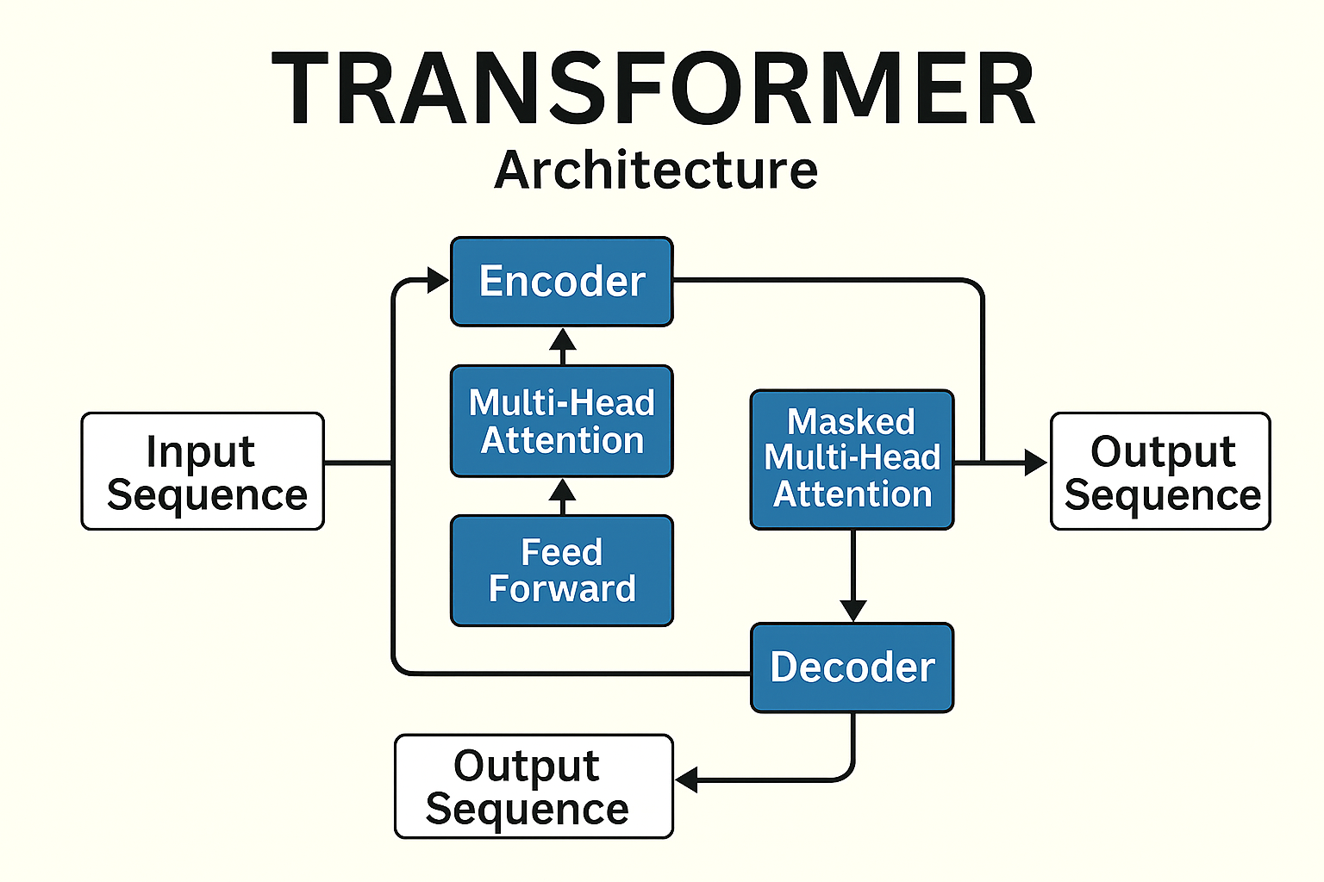

Steps:
1. Sequence Modeling Without Recurrence
Traditional models like RNNs and LSTMs process sequences sequentially, which limits parallelization and makes it hard to capture long-range dependencies.
The Transformer replaces recurrence with attention mechanisms, allowing global context modeling and parallel computation.

2. Input Representation
Let a sequence of tokens be:
X = [x1, x2, ..., xn]
To retain positional information, we add positional encodings:
zi = ei + PEi
Where PEi is the positional encoding for position iii.

3. Self-Attention Mechanism
The core idea is to compute a weighted sum of all tokens in the sequence, where the weights are determined by how relevant each token is to the current one.
a. Linear Projections
Each input vector zi ​ is projected into three vectors:
- Query: qi=ziWQ
- Key: ki=ziWK
- Value: vi=ziWV
Where WQ, WK, WV ​ are learned matrices.

b. Attention Scores
The attention score between token iii and token jjj is:
This is scaled to prevent large dot products that destabilize gradients.

c. Softmax Normalization
The scores are normalized

d. Weighted Sum
This allows each token to incorporate information from all other tokens.

4. Multi-Head Attention
Instead of one attention mechanism, we use hhh parallel heads:
- Each head has its own WhQ,WhK,WhV
- Outputs from all heads are concatenated:
MultiHead(Z) = Concat(head1,...,headh)WO
Where WO ​ is a learned matrix.
This allows the model to capture diverse types of relationships.

5. Position-Wise Feed-Forward Network
Each token’s output from attention is passed through a two-layer MLP:
This is applied independently to each token.

6. Residual Connections and Layer Normalization
To stabilize training and improve gradient flow, each sub-layer is wrapped with:
LayerNorm(x+Sublayer(x))
This is applied after both the attention and FFN layers.

7. Encoder and Decoder Structure
Encoder Layer:
Each encoder layer consists of:
- Multi-head self-attention
- Feed-forward network
- Residual + LayerNorm after each

Decoder Layer:
Each decoder layer consists of:
- Masked multi-head self-attention (prevents future token access)
- Multi-head attention over encoder output
- Feed-forward network
- Residual + LayerNorm after each

8. Training Objective
For tasks like translation or generation, the model is trained to maximize the likelihood of the correct output sequence

